


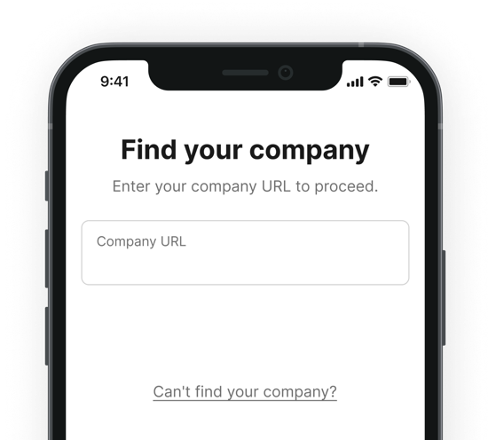
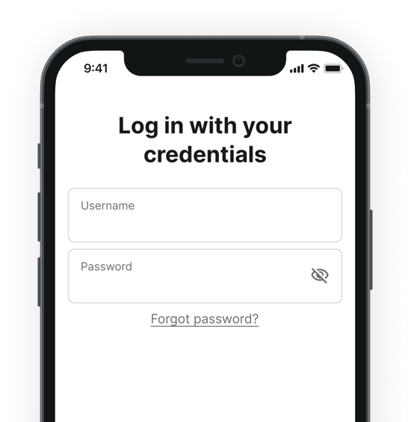




Welcome to the
«app_name_long» employee app

Scan the QR code with your phone's camera and download the app in the Play Store or App Store.

Next
Enter your company URL to get to the login of your company.
After the first login, you’ll be asked to set your own password.
The «app_name» Team

Hello «first_name» «last_name»,
We’re excited to introduce the «app_name_long» employee app — your new hub for company updates, communication, and essential information. Follow these simple steps to get started and stay connected!

«password»

«username»
«URL»

Log in
Password: «password»

Username: «username»

Log in with your credentials
3
«URL»

2
Enter your company URL
Download the app
Scan to download
On Desktop? Visit «URL»
1

